America250
Earlham Cemetery Walk
September 4, 2026
We gather to honor the 250th anniversary of the founding of the United States of America. The Madison County Genealogical Society celebrates the lives of Madison County men and women whose ancestors helped secure American independence during the Revolutionary War. Their patriot forefathers fought for liberty, endured hardship, and laid the foundation for the nation and the Madison County we know today.

Lucinda (Bingham) Carpenter Hibbs (1857-1946)
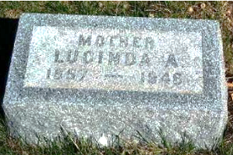
Lucinda was born in a log cabin north of Earlham, where her family lived with the widow of her great-great-grandfather, Moses Grigsby. Moses served in the Virginia Line of the Continental Army which was under the direct command of General George Washington. Lucinda’s father enlisted in the Civil War and was a casualty of Andersonville Prison. She and her husband farmed 40 years south of Earlham. She remained a living witness to stories that few others could tell—stories of pioneer cabins, frontier farming, Civil War sacrifice, and Earlham’s earliest days.

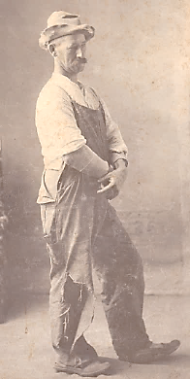
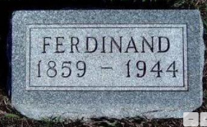
Ferdinand “Ferd” Bilderback (1859-1944)
Descending from Captain Ephraim Bilderback, who served on the Pennsylvania frontier during the Revolutionary War, Ferd was a man of many interests and talents. He was an apple-grower, bee keeper, plus a poultry man. He built three building that still anchor downtown Earlham. He loved entertainment as evidenced by managing the opera house and playing in the town band.

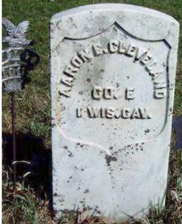
Aaron E. Cleveland (1846-1939)
Aaron’s Revolutionary War ancestor was also named Aaron Cleveland, who fought in the French and Indian War, as well the Revolutionary War. Our Aaron served in the 1st Wisconsin Cavalry during the Civil War. Since Union soldiers were permitted to vote for the president, even if underage, Aaron cast his first ballot for Abraham Lincoln in 1864. When he died at the age of 93, he was the last living Civil War veteran in Madison County.

Jasper Benson (1840-1918) / Josie Brown (1874-1961)
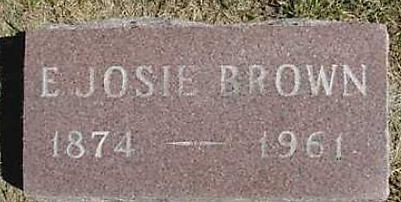
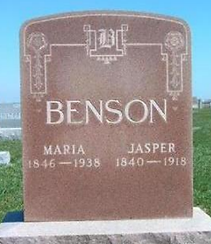
The Benson’s Revolutionary War heritage came though Stutson Benson, who served as a private in the New York 14th Albany County Militia. Jasper was a farmer and raised hogs. He also operated a lumber yard and built two existing buildings on the southeast corner of the downtown. His daughter, Josie, continued managing those buildings through many types of business. She was an independent woman and member of the Earlham Methodist Church for over 50 years.

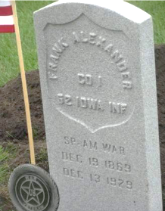
Franklin Alexander (1872-1929)
Frank’s Scottish great-great-grandfather, Reynold Alexander, fought for the Pennsylvania Militia in the Revolutionary War. The family tradition of military service continued into the War of 1812 and the Civil War. Frank served in the Spanish-American War. Without a gravestone, local groups submitted a request for a Veterans Administration-provided stone and set it, with full military ceremony, 90 years after his death in 2020.

Jennings Osborn (1844–1920) / Orman Osborn (1875–1957)
Matthew Osborn served in the North Carolina Militia during the Revolutionary War and was the great-great-grandfather of Jennings Osborn. Jennings (pictured) was born in Indiana and at the age of 18, enlisted in Company A of the 4th Indiana Cavalry. He moved to Earlham in 1880 with his wife and son, Orman. Here he was active in both the Grand Army of the Republic (GAR) Post J.P. Jones and the Masonic Lodge. He was a skilled laborer who laid brick sidewalks, cement curbing, and brick building veneers. His VA-provided gravestone was set in 2021, 100 years after his death.
His son, Orman, followed in the masonry trade as evidenced by building the water plant smoke stack, a stone fireplace in the city park, and the brick work for two buildings that still exist on the northeast corner of downtown. He worked in various states before coming home to care for his father.
